Monetary policy

- There are three types of financial markets

- Loan markets – in which business firms borrow money to purchase assets and capital equipment, and households borrow to fund their housing mortgage, buy consumer durables and pay for holidays – banks, finance companies and credit unions are part of the loan market
- Bond markets – in which firms and governments sell bonds to raise finance – a bond is known as a fixed interest security
- Share markets – in which firms can obtain finance by issuing new shares through the stock market

- Money functions as a medium/mean of exchange – an item that everyone is confident in using to trade, money is a unit of measurement
- Money measures and compares and compares prices, incomes and profit
- Money is a store of value – money can be saved and used for future transactions
- An important role for the government is to ensure that the financial sector is stable – different organisations which monitor and ensure this include the Reserve Bank of Australia (RBA), the Australian Securities and Investment Commission (ASIC) and Australian Prudential Regulation Authority (APRA)

Interest rates

- Interest rates are the price of money (the price of credit), where the nominal interest rate is the headline rate and the real interest rate is the headline rate minus inflation
- We have to pay people interest when we borrow money for a number of reasons; 1. To compensate for inflation, 2. To eliminate the risk of not being paid back, 3. Most people prefer to have their money in their possession (liquidity preference), so we compensate for their liquidity preference – all three counts are used to compensate the lender

The objectives of monetary policy

- The stability of the currency (price stability or low inflation)
- The maintenance of full employment (low unemployment)
- The economic prosperity and welfare of the people of Australian

- Inflation erodes the value of money in terms of currency and savings, so given a nominal value of an asset will diminish the value of the asset
- Inflation tends to reward ‘non-productive investment’, for example, renting out a house but not increasing the number of houses means that house prices increase with no production – hence, non-productive – it simply alters the value of assets
- Inflation rewards borrowing and punishes lending, and high inflation will also jeopardise our international trade as goods from overseas will become relatively cheap but our goods overseas will be more expensive

How is monetary policy implemented?

- Monetary policy is implemented through the cash rate; the cash rate is the interest rate which the RBA charges on overnight loans by Australian banks (e.g., Bendigo, Westpac, ANZ etc.) – in theory, when the cash rate rises, the interest rates on financial products also rise as the interest rate they are charged by the RBA are also increased
- The RBA announces a cash rate target, then uses open market operations (OMOs) to achieve that target in the interbank market – the market is made up of banks and a small number of other financial institutions, which are collectively known as approved deposit-taking institutions (ADIs)
- Banks keep ‘exchange settlement accounts’ at the RBA in order to settle their day-to-day transactions – the daily demand for cash in ESA accounts fluctuates as banks meet their mutual obligations, and banks either borrow or deposit from/in the RBA
- The RBA supplies the funds to maintain liquidity through repurchase agreements (repos), government bonds and foreign exchange swaps
- Changes to the cash rate target are generally made in small amounts, often 0.25 percentage points (25 basis points)

Monetary policy stances

- An upward cash rate movement over a period of time is described as a ‘contractionary’ monetary stance to decrease aggregate demand, and a downward movement is an ‘expansionary stance’ to increase aggregate demand
- Under normal circumstances, the cash rate would be above the underlying inflation rate which was not seen from 2019 onward – we’ve had a negative cash rate which means there is reduced incentive to put money in the bank
- The cash rate target in Australia has been falling since 2015, reflecting weakness in the economy after the mining boom, then the onset of the COVID-19 pandemic

Transmission mechanism
When the cash rate is reduced: (aggregate demand will decrease!)
This affects all other interest rates. When interest rates are low, the cost of borrowing decreases as less repayments need to be made on the loans, therefore increasing C and I. Lower interest repayments increase the cash flow available for businesses and households, increasing C and I. Increased accessibility of credit increases demand assets (such as property) increasing household perception of wealth and hence, increasing consumption. Lower returns on foreign investment result in a fall in demand for the currency, depreciating it. This increases the international competitiveness of exports and reduces the competitiveness of imports. This increases net exports.

When the cash rate is increased: (aggregate demand will increase!)
This affects all other interest rates. When interest rates are high, the cost of borrowing increases as there are higher repayments that need to be made, therefore discouraging C and I. An increase in market interest rates means that households and businesses have to meet higher interest repayments, hence reducing cash flow available for consumption and investment. An increase in interest rates reduces the accessibility to credit to purchase assets such as property. Reduced demand will reduce property prices, decreasing household perception of wealth and hence, lowering consumption. A rise in market interest rates attracts foreign investment as the returns on investment are greater. An increase in foreign investment represents an increased demand for the currency, appreciating the dollar. This reduced the international competitiveness of exports and increases the competitiveness of imports, reducing net exports.

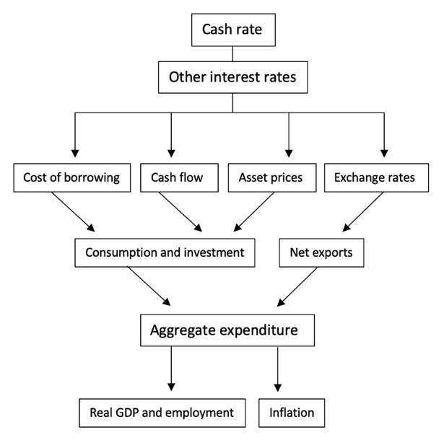

The impact of monetary policy

- Monetary policy affects the level of aggregate demand which can be shown using the Keynesian model or the classical model
- The effect of the expansionary monetary policy is shown to the left, where low cash rates encouraged aggregate demand through the transmission mechanism
- The increase in aggregate demand from AD₁ to AD₂ will increase GDP from Y₁ to Y₂, which will also stimulate employment
- The change from AD₁ to AD₂ as shown will also increase price levels from P₁ to P₂
- This is appropriate as there is still spare capacity in the economy, and the cash rates are stimulating inflation towards the target band of between 2-3%
Keynesian AD/AS: Expansionary monetary policy

- The effect of the contractionary monetary policy is shown to the left
- High levels of aggregate demand are reduced by high cash rates, which through the transmission mechanism, discourages private spending and net exports
- The contractionary monetary policy reduces AD from AD₁ to AD₂
- While this results in a fall in real GDP from Y₁ to Y₂ and some increases in unemployment, it’s beneficial to the economy as it results in a larger fall in price levels from P₁ to P₂
- P₂ represents the target inflationary band of the Reserve Bank at 2-3%
Keynesian AD/AS: Contractionary monetary policy

Strengths and weaknesses of monetary policy

Strength of monetary policy | Weaknesses of monetary policy
Short decision and implementation lags: Monetary policy decisions are made on the first Tuesday of each month and react shortly to changes in the economic climate, thus having a short decision lag | Blunt instrument: Monetary policy applies to all industries, sectors and states equally, regardless of different levels of growth, hence being called a ‘blunt instrument’ – cannot be directed
Effect during booms: Increasing the cost of borrowing is an effective method of combating high levels of economic activity – increases in cash rates have an immediate effect on households and firms cash flow and an immediate increase in investment risk | Long effect lag: Monetary policy has a long effect lag as it works indirectly through the transmission mechanism to reduce or increase aggregate demand – to combat this, the RBA makes the cash rate decisions based on the mid-term economic outlook
No political influence: The RBA isn’t influenced by the political spectrum of government but is an independent authority where all decisions made by the bank are solely based on economic reasons to achieve the RBA’s three economic objectives | Ineffective during a trough: During a trough, low levels of economic activity create a lack of confidence in the economy that outweighs the benefits of low cash rates – households will still save despite low deposit rates
Strong links to exchange rate: Changes in the cash rate often have an immediate effect on the exchange rate – in most cases, changes to the cash rate are followed by expected market movements in the floated exchange rate of the AUD | The liquidity trap: When interest rates are low, and unemployment rates are high, economic outlook is bleak and despite interest rates people are not borrowing money – they are not confident

Recent monetary policy in Australia

In 2008, cash rate was 7%. The GFC led to a decline in the global economy, and to some extent the domestic economy. But the government chose to tackle the GFC using fiscal policy (by spending money). Simultaneously, monetary policy was used as the cash rate was placed at 3%. After the GFC had finished, by 2011, the cash rate was approximately 5%. The target cash rate has fallen since 2011, falling to below 1% in 2019 (following a steady decline). Real interest rates was negative (less than inflation), and during this period low interest rates did not achieve its goal of growth in the economy.

Causes may have been the current level of debt (at that time) which may have been high, so they were not in a position to borrow more. High level of debt preference, which has declined since the GFC. Wage growth was slow during this period. Underemployment was increasing, as full-time workers were made to be part-time, which would affect the level of income, and therefore affect the confidence in borrowing. Australia’s exchange rate was high during this period due to the fact that we had higher interest rates relative to our competing nations. This led to a high level of capital inflow, meaning our exports are expensive, our imports are cheaper, which does not assist in creating growth. After the GFC, baby boomers were hit the heaviest as the shares in their super declined along with their house prices.

Unconventional monetary policy

- In March 2020, the RBA announced that it would commence using other instruments, in addition to the cash rate, “to lower funding costs and support the supply of credit” (RBA, 2020)

- Quantitative easing (QE)
- A term funding facility to deposit-taking institutions
- Forward guidance
- Changes to interest rates of exchange settlement accounts by authorised deposit-taking institutions (ADIs)

- The government sells bonds to finance its spending, especially when the budget is in deficit – they’re typically purchased by investors and institutions like superannuation funds seeking to hold a proportion of safe assets in their portfolio
- The primary bond market is where the government initially sells the bonds to raise finance, and the bonds can then be traded by the public (investment companies and institutions) in the secondary market

Unconventional monetary policy
Quantitative easing (QE)
Quantitative easing is when the RBA buys government bonds on the secondary market. This increases demand for bonds in the market, and thus their price. When the price of a band rises however, its effective yield falls, which is why QE drives down interest rates. In theory, this increases the money supply which effectively pumps cash into the economy. When the banks have more money, they can lend more readily to businesses and consumers, which in turns leads to greater spending, and ultimately more economic activity. QE has risks however; it can push up asset prices if the cash pumped into the economy increases the demand for housing or shares in public companies, and can reduce the incentive to save as it drives interest rates lower.
Term Funding Facility (TFF)
The RBA announced a $90bn TFF, which provides three-year funding for approved deposit-taking institutions such as banks at a fixes interest rate of 25 basis points (0.25%). The objective is to provide financial institutions with greater confidence about their access to funding, and to lower their funding costs, which can be passed on as lower household and business borrowing costs.
Forward guidance
The Reserve Bank issued notice that the short to medium term (approximately 3 years) future would be one which had low interest rates, and this would remain the case until inflation reaches the 2-3% range. The focus now is on reducing unemployment levels.
Changes to interest rates on ESAs by ADIs
The new cash rate is 0.1%, and this has been put in place to minimise the costs to banks in performing normal business operations, so that they can lend at the most competitive rate to businesses to encourage investment and growth in employment.

